VIRTUAL TOOLKIT: MISSION 1
STEP-BY-STEP

To solve this Mission you will be using the digital forensic copies and a backup of data from two phones. These are called Portable Case files. You will want to review each one of them STARTING with the Kara files (001 & 002). They are located in the Mission 1 folder:

001 Portable Case – Kara Phone
002 Portable Case – Kara Phone Backup
003 Portable Case – Suspect Phone

Be sure to save the data you extract into the My Recovered Data folder.
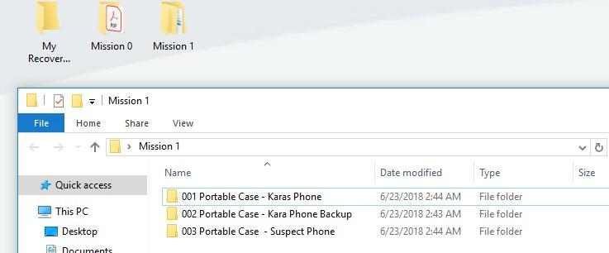

EXAMPLE OF HOW TO OPEN A PORTABLE CASE FILE:

1. Navigate to Mission 1 → 001 Portable Case – Karas Phone Folder
2. Right-Click on OpenCase and select Run As Administrator (Very Important!)

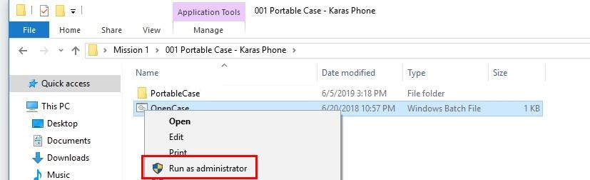

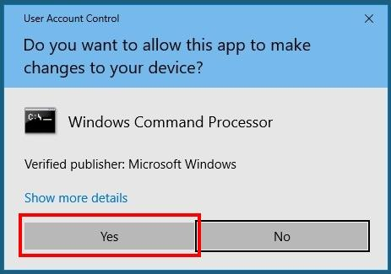
3. Click Yes on the pop-up window:

4. Click NO THANKS in the pop-up window (appears when opening for the first time).

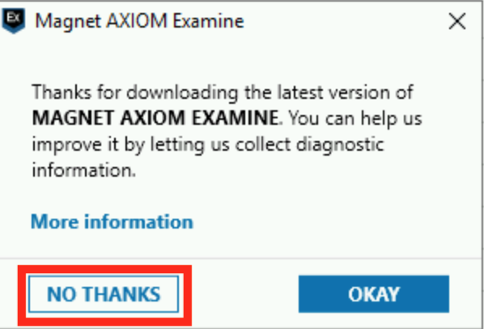

TIPS FOR SEARCHING AND VIEWING THE PORTABLE CASE FILE:
Forensics tools organize large volumes of data into file types. Examiners can quickly SORT through ALL evidence to find email, chat, photos and other media.

1. In the Portable Case File you can View the data in different ways:
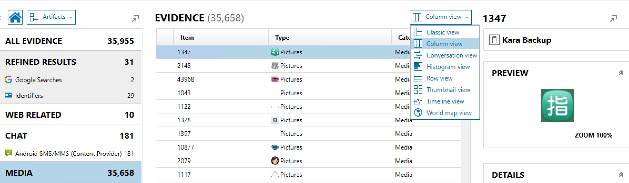

2. Column View is a good way to review MESSAGES
You can sort information by Participants to look at information associated with a phone number.

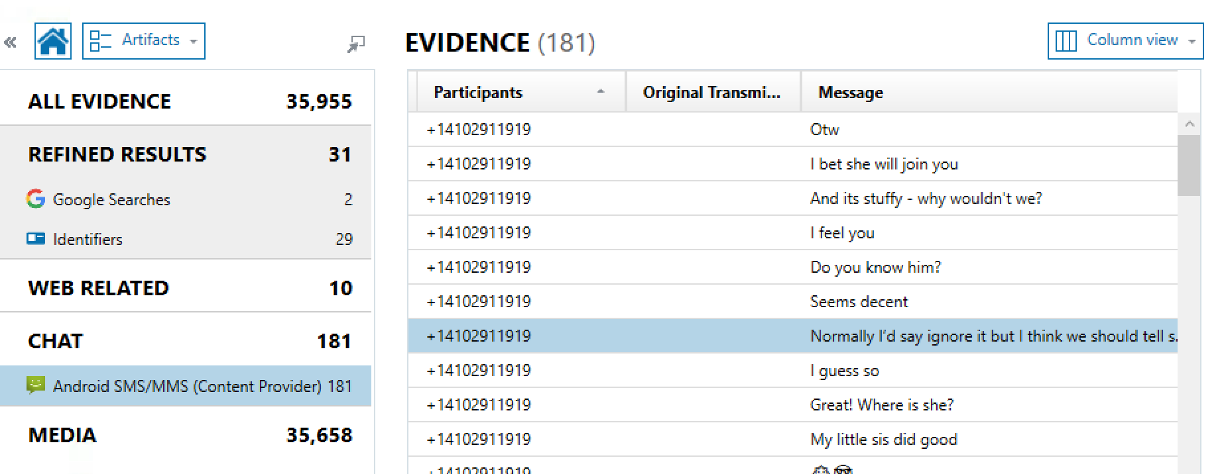

Thumbnail View is a good way to search PICTURES

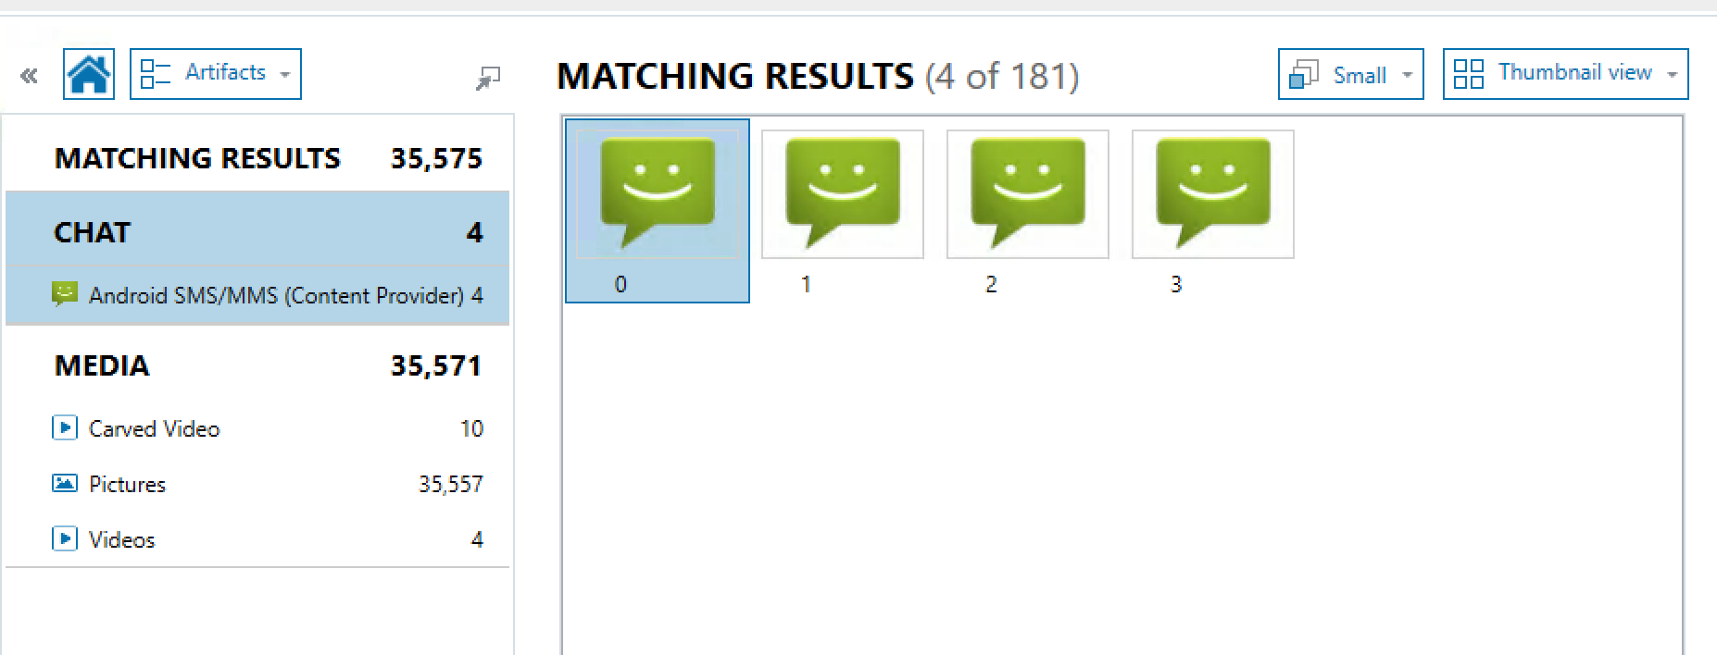

Enter keywords in the SEARCH box to highlight items of interest.

If you get lost, REMEMBER you can use the HOME Button at any time
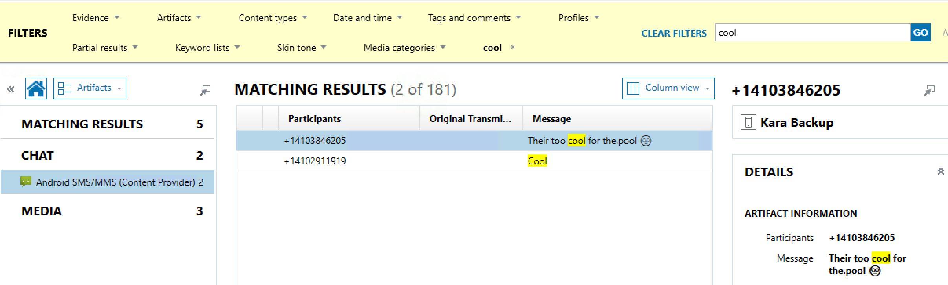

3. Use the SCROLL BAR at the bottom to be sure you are viewing all the columns.

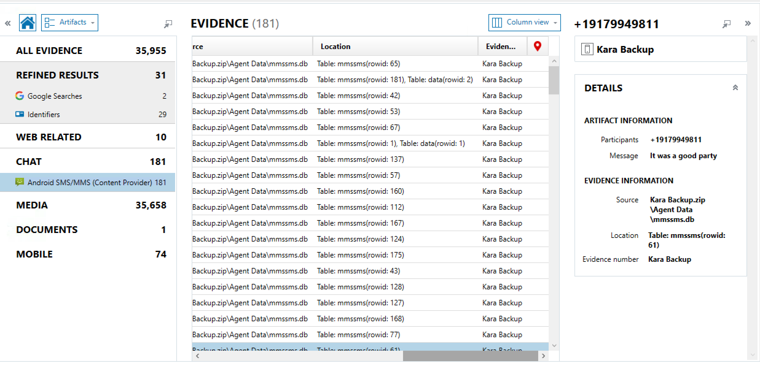

4. Right mouse-click to Tag files “Of interest” or as “Evidence”

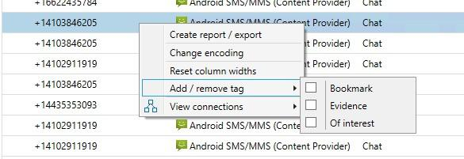

5. Right mouse-click will also allow you to save an evidence item to a folder on your desktop.

