VIRTUAL TOOLKIT: MISSION 0
STEP-BY-STEP
To View Virtual Toolkit and Cyber Sleuth Lab at the same time MINIMIZE the toolkit window.
GOTO Window → Exit Full Screen

FIND THE ANSWERS

Document your answers in your Lab Notebook.

Were you able to recover a deleted photo? Why?
- I was able to recover the photo because…

What information were you able to uncover about the photo recovered in Autopsy?
- How many photos did you recover?
- When were the photos most likely taken?
- What specific device was used to take the photos?

What additional information did you learn about the photos by looking at the EXIF metadata in JPEGsnoop? Is location information indicating where the photo was taken in the EXIF metadata?

Be sure to list: the date you conducted the investigation; the step-by-step process involved in recovering the data; and the digital forensic tools and versions used to recover the photo and examine the EXIF metadata.

Copy into your Lab Notebook: (1) the Image Log located in the Mission 0 folder on the Toolkit’s desktop and (2) the EXIF metadata in JPEGsnoop from the photo you recovered.

TIP: Copy and paste the SDCard log and also the EXIF metadata from a recovered photo into the notebook.

BEFORE YOU BEGIN

EXAMINE & COPY THE IMAGE LOG INTO THE LAB NOTEBOOK

The Image Log is documentation generated when the Forensic Copy of the data was created.
- Open SDCard_ImageLog.txt found in Desktop → Mission 0 → SDCard
- Take a look at the types of information found in the Image Log
- Copy the Image Log text to your Lab Notebook:
1. Edit → Select All or [CNTRL]-[a] / [CMND]-[a]
2. Edit → Copy or [CNTRL]-[c] / [CMND]-[c]
3. In the Lab Notebook, click on [ADD NEW DATA] button at the bottom of the window
4. Type Image Log in the Title Field
5. Right-Click in the Data area and select Paste or [CNTRL]-[v] / [CMND]-[p]
6. Click [SAVE]

INVESTIGATE – PART 1
Using Autopsy to Recover Deleted Data

OPEN AUTOPSY

- Open Autopsy (wait for it to open)
- Select “No” when window pops up “Enable Central Repository”
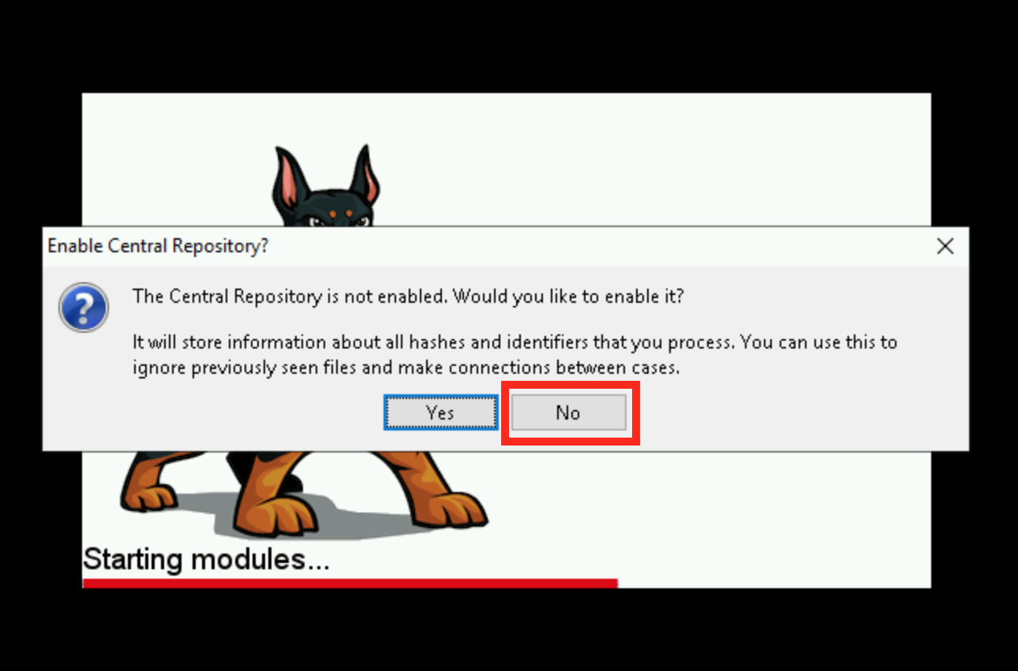

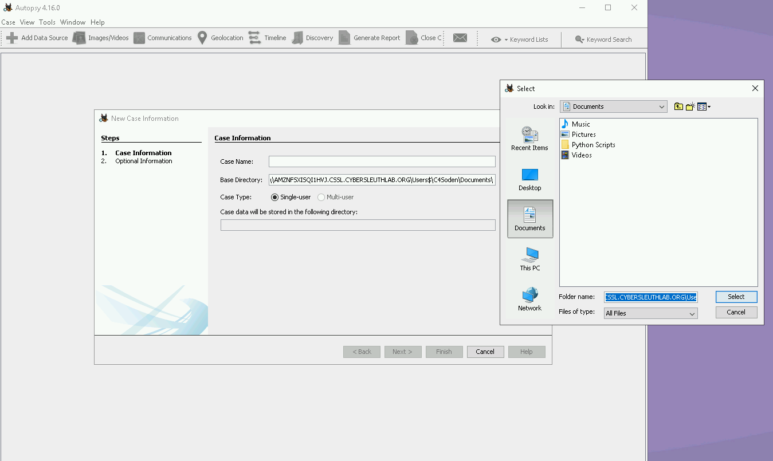

STEP 1 Create a New Case

- Select Create New Case

- Enter a Case Name

- Enter Base Directory
IF Base Directory doesn’t automatically load
Click [Browse] and choose Documents
Click [Select]
Click [Next]

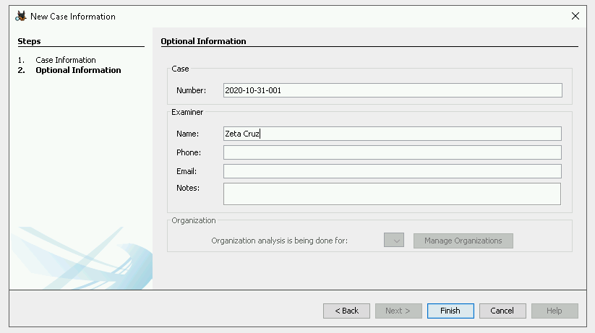
Case data will be stored in this directory.

- Additional Information:
Enter Case Number
today’s date / case of the day
Example: 2020-1031-001

Enter Examiner Name
(your code name)
Click [Finish]

STEP 2 Add Case Data

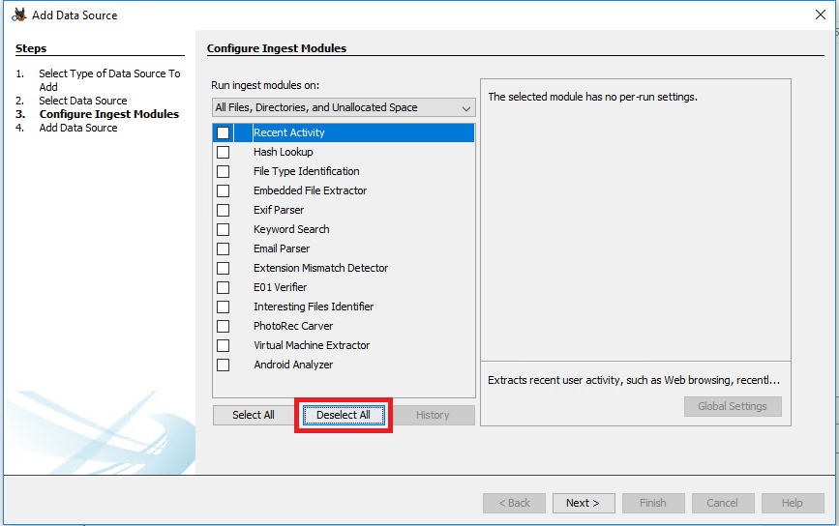
- Select Type of Data
Disk Image or VM File on
Add Data Source screen
Click [Next]

- Select Data Source
Browse to select the appropriate case data file (located in Mission 0 folder on desktop)
Click [Open]
Click [Next]

- In the Configure Ingest Module window
Deselect All check boxes
Click [Next]
Click [Finish]

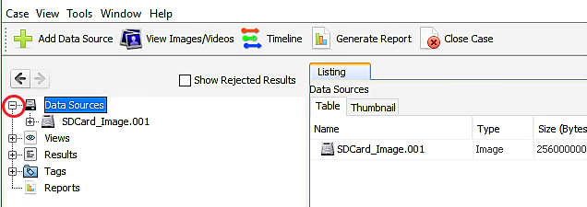
STEP 3 Review the Case Data

- Open the DATA SOURCES folder on the top left

- Click on the words SDCard_Image.001 to display the items in the Listing window to the right

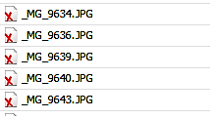

- Determine If you successfully recovered any deleted files
Files Marked with a Red X = Deleted Files

Successfully Recovered Files = File Size is greater than 0

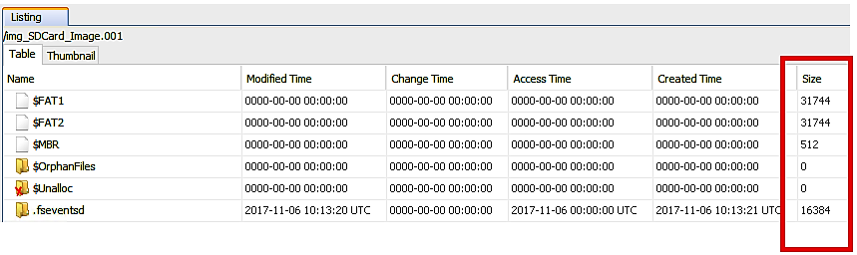

- Click on the Thumbnail tab to see if any of the recovered files are photos

- Select a Recovered Photo

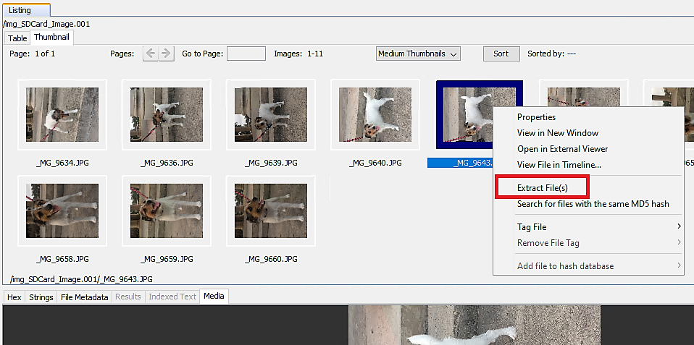
STEP 4 Extracting The Results

- Right Click on the recovered Photo you want to use

- Choose Extract File from the drop-down box

- Rename the file by entering your code name

- Save the File on the Desktop in
Mission 0 → RecoveredPhoto folder

STEP 5 More Detailed Analysis

- Highlight the photo you want to investigate in Autopsy so that image appears in the viewer
- Select the STRINGS tab to view the information embedded in the image

INVESTIGATE – PART 2
Using JPEGsnoop to Review EXIF Metadata

Open JPEGsnoop
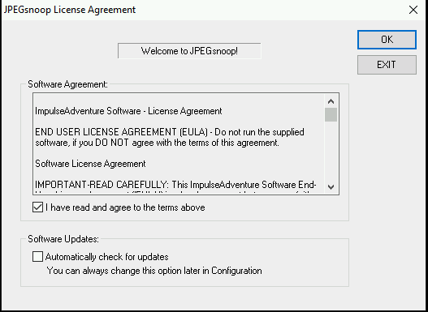

- Select File, Open Image and Select the photo you saved in the RecoveredPhoto folder
- Examine the EXIF metadata stored in the image
- Copy and paste the EXIF metadata to your Lab Notebook (SEE TIP 1 BELOW)

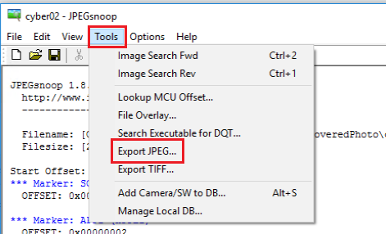
- Copy and paste the photo to your computer’s desktop
- In JPEGSnoop, click on Tools → Export JPEG

- Leave all Settings unchecked and click [OK]
- Save the File in the Desktop → Mission 0 → RecoveredPhoto folder
- Right-Click on the icon/name for the file and select copy.
- Back on your local Desktop, right-click and select paste.

TIP 1 – Copy and Paste to Lab Notebook

1. Edit → Select All or [CNTRL]-[a] / [CMND]-[a]
2. Edit → Copy or [CNTRL]-[c] / [CMND]-[c]
3. Over in the Lab Notebook, click on [ADD NEW DATA] button at the bottom of the window
4. Type JPEGSnoop EXIF DATA in the Title Field
5. Right-Click in the Data area and select Paste or [CNTRL]-[v] / [CMND]-[p]
6. Click [SAVE]

