BRIEF

CHALLENGE:
There are five files that have issues when trying to open them. Your help is needed to fix these files. To do this you will need to determine the issue with the files and how to fix them using a Hex Editor.

STEP 1 - DISCOVER
Review the interactive Online Discovery Brief to learn:
- Different types of file issues: corrupted file, file with wrong file extension, file embedded in another file
- How to identify File Type by its Hex signature and ASCII identifier
- How to use a Decision Flow Chart to identify the file issue
- How to use an online Hex Editor to fix the file

Once you have completed the Online Discovery Brief, continue on to Step 2: Investigate Folder to fix the issues with the 5 Challenge Files.

STEP 2 – INVESTIGATE FOLDER
There are 5 Challenge Files. Each file has an issue.
- Use the Decision Flow Charts on the last page to determine the issue with file.
- Use the File Signature Key to determine a file type by its Hex signature and ASCII identifier.
- Use the online Hex Editor to fix the files. To do this follow what you learned in the Online Discovery Brief. There is also a Hex Editor Tips & Reference Guide in the Investigate Folder
- Here is the link to the online Hex Editor: https://hexed.it

When you fix the 5 files and open them you will find a code word. Keep track of the answers in the Scorecard on the next page.

STEP 3 - REPORT
- After you have fixed as many files as you have time for enter the code words in the Online Mastery Scorecard to collect flags for this SideQuest.
- Take a snapshot of the flags you have collected and turn it in.

SCORECARD

CHALLENGE | File Issue | Code word
Challenge 1
File 1_Passwords

Challenge 2
File 2_Forest

Challenge 3
File 3_Prague

Challenge 4
File 4_Aurora

Challenge 5
File 5_Beach

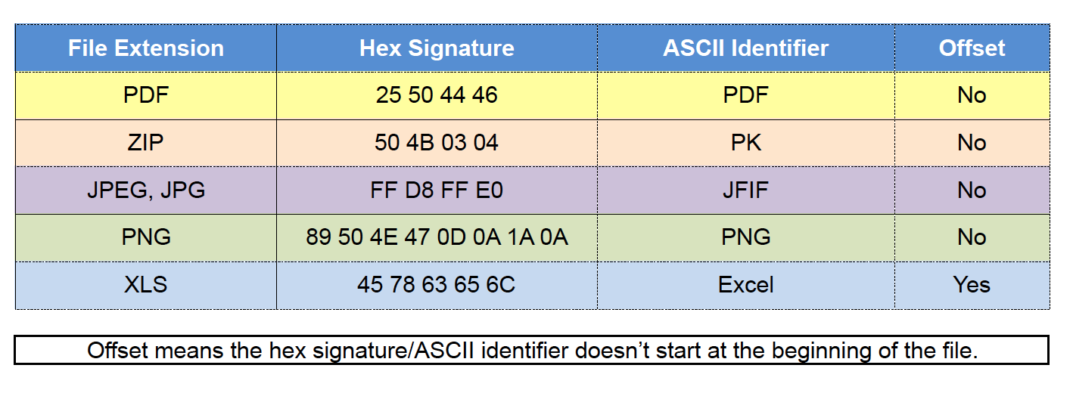
FILE SIGNATURE KEY
Source: https://www.garykessler.net/library/file_sigs.html

DECISION FLOWCHART
