Challenge 1

QUESTION: How much is Igor offered to steal a painting?

CLUE TO THE ANSWER: _ _ _ _ _ _ _ _ _ _ _ (2 words)

Decode the email message to answer the above question. To do this, use the Scratchpad below the email. The hex encoded message has already been entered into the Scratchpad.

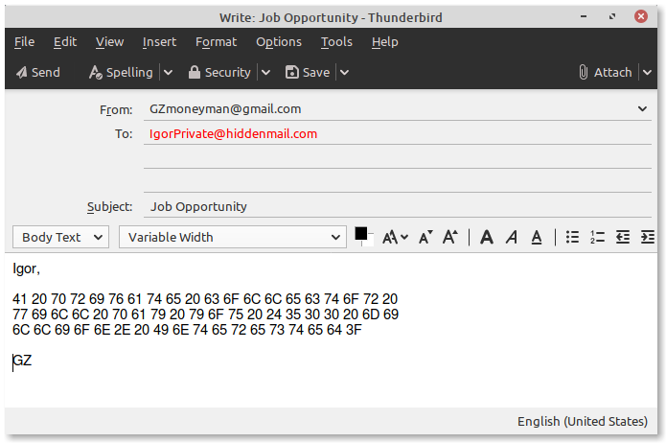
Image of the Hex Encoded Email:

Note:
Hex value 20 = “space” in ASCII Text

HEX SCRATCHPAD
 | 1 | 2 | 3 | 4 | 5 | 6 | 7 | 8 | 9 | 10 | 11 | 12 | 13 | 14 | 15 | 16 | 17 | 18 | 19 | 20
HEX | 41 | 20 | 70 | 72 | 69 | 76 | 61 | 74 | 65 | 20 | 63 | 6f | 6c | 6c | 65 | 63 | 74 | 6f | 72 | 20
ASCII
HEX | 77 | 69 | 6c | 6c | 20 | 70 | 61 | 79 | 20 | 79 | 6f | 75 | 20 | 24 | 35 | 30 | 30 | 20 | 6d | 69
ASCII
HEX | 6c | 6c | 69 | 6f | 6e | 2e | 20 | 49 | 6e | 74 | 65 | 72 | 65 | 73 | 74 | 65 | 64 | 3f
ASCII

challenge 2

QUESTION: Based on the map coordinates what is the name of the museum they will rob?

CLUE TO THE ANSWER: _ _ _ _ _ _ _ _ _ (2 words)

Decode the email message to answer the above question. To do this, use the Scratchpad below the email. The hex encoded message has already been entered into the Scratchpad.

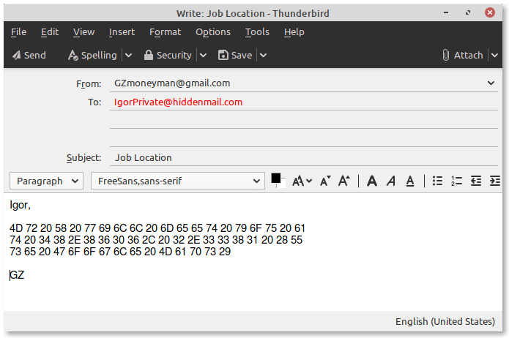

Image of the Hex Encoded Email:

Note:
Hex value 20 = “space” in ASCII Text

HEX SCRATCHPAD
 | 1 | 2 | 3 | 4 | 5 | 6 | 7 | 8 | 9 | 10 | 11 | 12 | 13 | 14 | 15 | 16 | 17 | 18 | 19 | 20
HEX | 4D | 72 | 20 | 58 | 20 | 77 | 69 | 6C | 6C | 20 | 6D | 65 | 65 | 74 | 20 | 79 | 6F | 75 | 20 | 61
ASCII
HEX | 74 | 20 | 34 | 38 | 2E | 38 | 36 | 30 | 36 | 2C | 20 | 32 | 2E | 33 | 33 | 38 | 31 | 20 | 28 | 55
ASCII
HEX | 73 | 65 | 20 | 47 | 6F | 6F | 67 | 6C | 65 | 20 | 4D | 61 | 70 | 73 | 29
ASCII

Challenge 3

QUESTION: What painting does GZ want Igor to steal?

CLUE TO THE ANSWER: _ _ _ _ _ _ _ _ (2 words)

Decode the email message to answer the above question. To do this, use the Scratchpad below the email. The hex encoded message has already been entered into the Scratchpad.

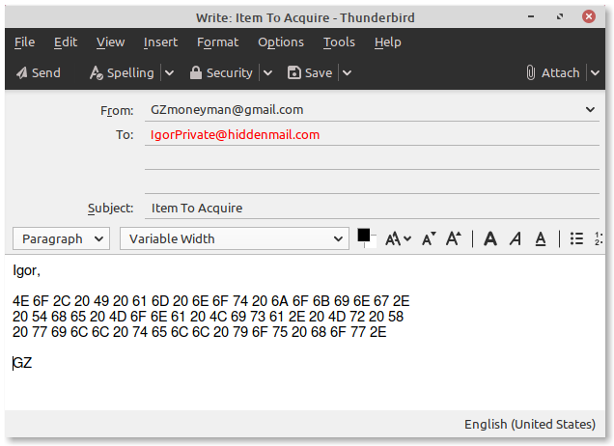

Image of the Hex Encoded Email:

Note:
Hex value 20 = “space” in ASCII Text

HEX SCRATCHPAD
 | 1 | 2 | 3 | 4 | 5 | 6 | 7 | 8 | 9 | 10 | 11 | 12 | 13 | 14 | 15 | 16 | 17 | 18 | 19 | 20
HEX | 4E | 6F | 2C | 20 | 49 | 20 | 61 | 6D | 20 | 6E | 6F | 74 | 20 | 6A | 6F | 6B | 69 | 6E | 67 | 2E
ASCII
HEX | 20 | 54 | 68 | 65 | 20 | 4D | 6F | 6E | 61 | 20 | 4C | 69 | 73 | 61 | 2E | 20 | 4D | 72 | 20 | 58
ASCII
HEX | 20 | 77 | 69 | 6C | 20 | 74 | 65 | 6C | 20 | 79 | 6F | 75 | 20 | 68 | 6F | 77 | 2E
ASCII

Challenge 4

QUESTION: Which train station will GZ meet Igor at after the robbery?

CLUE TO THE ANSWER: _ _ _ _ _ _ _ _ _ _ _ _ _ _ _ (map coordinates)

Decode the email message to answer the above question. To do this, use the Scratchpad below the email. The decimal encoded message has already been entered into the Scratchpad.

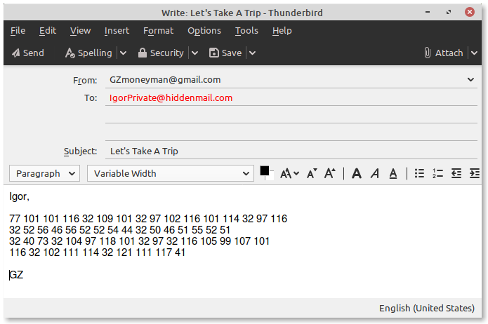

Image of the Decimal Encoded Email:

Note:
Decimal value 32 = “space” in ASCII Text

DECIMAL SCRATCHPAD
 | 1 | 2 | 3 | 4 | 5 | 6 | 7 | 8 | 9 | 10 | 11 | 12 | 13 | 14 | 15 | 16
DEC | 77 | 101 | 101 | 116 | 32 | 109 | 101 | 32 | 97 | 102 | 116 | 101 | 114 | 32 | 97 | 116
ASCII
DEC | 32 | 52 | 56 | 46 | 56 | 52 | 52 | 54 | 44 | 32 | 50 | 46 | 51 | 55 | 52 | 51
ASCII
DEC | 32 | 40 | 73 | 32 | 104 | 97 | 118 | 101 | 32 | 97 | 32 | 116 | 105 | 99 | 107 | 101
ASCII
DEC | 116 | 32 | 102 | 111 | 114 | 32 | 121 | 111 | 117 | 41
ASCII

Challenge 5

QUESTION: To get paid what country do Igor and GZ need to travel to?

CLUE TO THE ANSWER: _ _ _ _ _ _ _ _ _ _ _

Decode the email message to answer the above question. To do this, use the Scratchpad below the email. The binary encoded message has already been entered into the Scratchpad.

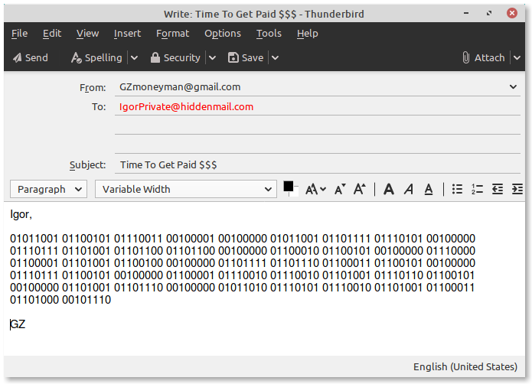
Image of the Binary Encoded Email:

Note:
Binary value 00100000 = “space” in ASCII Text

BINARY SCRATCHPAD
 | 1 | 2 | 3 | 4 | 5 | 6 | 7 | 8 | 9
BIN | 01011001 | 01100101 | 01110011 | 00100001 | 00100000 | 01011001 | 01101111 | 01110101 | 00100000
ASCII
BIN | 01110111 | 01101001 | 01101100 | 01101100 | 00100000 | 01100010 | 01100101 | 00100000 | 01110000
ASCII
BIN | 01100001 | 01101001 | 01100100 | 00100000 | 01101111 | 01101110 | 01100011 | 01100101 | 00100000
ASCII
BIN | 01110111 | 01100101 | 00100000 | 01100001 | 01110010 | 01110010 | 01101001 | 01110110 | 01100101
ASCII
BIN | 00100000 | 01101001 | 01101110 | 00100000 | 01011010 | 01110101 | 01110010 | 01101001 | 01100011
ASCII
BIN | 01101000 | 00101110
ASCII

